Smart Energy Monitor with GUI (Python + Raspberry Pi)

ABSTRACT
The Smart Energy Monitor is a Python-based application designed to simulate real-time monitoring of power usage in household appliances. It uses a graphical user interface (GUI) to prompt the user for authentication (username and password) and allows the selection of various home appliances such as TV, Fan, Fridge, and Lights. The application simulates voltage and current readings for the selected device, calculates the power consumed, and determines the cost based on a predefined unit rate. Data is stored in a CSV file for analysis and is visually presented using Matplotlib charts. This project aims to create awareness of energy consumption and cost management, providing users with an intuitive and interactive way to track energy usage efficiently.

TABLE OF CONTENTS
NUMBER | CONTENT | PAGE NUMBER
1. | INTRODUCTION | 2
2. | SYSTEM PROPOSAL | 2
3. | FLOW DIAGRAM | 1
4. | IMPLEMENTATION | 3
5. | SYSTEM REQUIREMENTS | 7
6. | INTRODUCTION TO SMART ENERGY MONITOR | 3
7. | SOURCE CODE OF THE PROJECT | 6
8. | SCREEN SHOTS | 2
9. | FUTURE ENCHANCEMENT | 2
10. | CONCLUSION | 1

Introduction
1.1 General Introduction
Electricity is one of the most essential resources in our daily lives. With the increasing use of electrical appliances, it becomes important to monitor energy consumption to reduce wastage and control electricity bills. Traditional energy meters only show total usage but do not tell which appliance is using how much energy. This makes it difficult to understand where energy is being used the most.
The Smart Energy Monitor project is developed using Python and Raspberry Pi to simulate real-time monitoring of power usage for individual appliances. It helps users understand how much current each appliance is consuming and how much it costs.
This system collects data for a selected appliance (like TV, Fan, Fridge, etc.), calculates the power consumed, estimates the total cost, stores the data, and finally displays it using charts.
1.2. Project Objectives
The main goals of this project are:
- To develop a user-friendly Python application to monitor real-time energy usage.
- To allow users to log in securely and select specific home appliances for monitoring.
- To simulate voltage and current readings and calculate power consumption.
- To calculate the total cost of energy consumed based on a predefined unit price.
- To store the power usage data in a CSV file for future records.
- To display a power usage chart for easy understanding of energy consumption trends.

1.3.Problem Statement
In most homes and offices, users are unaware of how much electricity each device consumes. This lack of visibility often leads to high electricity bills and energy wastage. Traditional energy meters only show total usage, not the breakdown per appliance.
The problem is:
- No real-time monitoring of each appliance.
- No estimation of cost per device usage.
- No visual representation of power consumption.
This project aims to solve these issues by building a Python-based smart energy monitor that gives detailed information about energy usage, cost, and trends for individual appliances.

System Proposal
2.1. Existing System
In most households and commercial places, energy usage is measured using traditional analog or digital electricity meters. These meters display only the total units consumed over time, without any information about which appliance is using how much electricity. Users receive monthly electricity bills without knowing the breakdown of consumption.
2.2.1. Disadvantages of the Existing System
- No Real-Time Monitoring – Users cannot track current power usage in real time.
- No Appliance-wise Breakdown – There is no way to know which device is using how much power.
- No Cost Estimation – Users can’t see how much money each device is costing them.
- Manual Monitoring – Any tracking needs to be done manually, which is not practical.
- No Visual Reports – There are no charts or visual summaries to understand usage trends.

2.2. Proposed System
The proposed Smart Energy Monitor is a Python-based application connected to sensors (simulated in this project) that monitors the real-time energy consumption of selected home appliances. The system uses a GUI for login, device selection, and shows charts of power usage. It stores all usage data and provides cost calculation for better management of electricity consumption.
2.2.1. Advantages of the Proposed System
- Real-Time Monitoring – Users can see current usage instantly.
- Device-wise Tracking – The system shows how much each appliance consumes.
- Automatic Cost Calculation – It calculates how much the user needs to pay.
- CSV Data Storage – All records are stored for monthly reports and analysis.
- User-Friendly GUI – Easy to use interface for login and appliance selection.
- Visual Charts – Shows power consumption graphs for better understanding.

SYSTEM DIAGRAMS
3.1. FLOW DIAGRAM
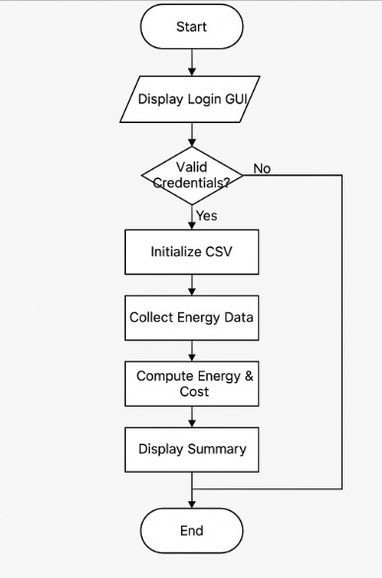
Output

IMPLEMENTATIONS
The Smart Energy Monitor application is implemented in Python using a modular approach. It uses GUI (Tkinter) for user interaction, simulates real-time sensor readings, calculates power usage, and visualizes the data with Matplotlib.
4.1.MODULES:
The project is divided into the following modules:
- Login Module
- Application Selection Module
- Sensor Simulation Module
- Data Processing Module
- Data Storage Module
- Visualization & Summary Module
4.2.MODULES DESCRIPTION:
1. Login Module
- Purpose: Authenticates the user using a predefined username and password.
- Tools Used: Tkinter for GUI, basic Python logic for credential verification.
- Functionality: Prevents unauthorized access and ensures only valid users can use the application.
2. Application Selection Module
- Purpose: Allows users to select the appliance they want to monitor (e.g., TV, Fan1, Fan2).
- Tools Used: Tkinter dropdown (Combobox).
- Functionality: Stores the user’s selected appliance and tags each data sample accordingly.
3. Sensor Simulation Module
- Purpose: Simulates voltage and current readings as real sensor data is not connected.
- Tools Used: Python’s random.uniform() to simulate values.
- Functionality: Mimics real-time sensor behavior by generating values every 0.5 seconds.
4. Data Processing Module
- Purpose: Calculates power consumption from voltage and current.
- Formula Used: Power (W) = Voltage × Current
- Functionality: Computes power values in watts and total energy in kWh, used later for cost calculation.
5. Data Storage Module
- Purpose: Stores all the sensor readings into a CSV file.
- Tools Used: Python’s csv module.
- Functionality: Appends timestamped data for later analysis and visualization.
6. Visualization & Summary Module
- Purpose: Displays a summary chart and calculates total cost.
- Tools Used: Pandas for reading CSV, Matplotlib for chart plotting.
- Functionality: Shows real-time power usage graph, total energy consumed, and amount in ₹ based on a predefined unit cost.

SYSTEM REQUIREMENTS
This section outlines the hardware and software needed to develop and run the Smart Energy Monitor application successfully.
5.1. HARDWARE REQUIREMENTS:
Component | Specification
Processor | Intel i3 or higher
RAM | Minimum 4 GB
Storage | Minimum 100 MB of free disk space
Display | Any display supporting 1024×768 or more
Optional Hardware | Raspberry Pi (for future real sensor use)

  - SOFTWARE REQUIREMENTS:
Software | Version/Details
Operating System | Windows 7/8/10/11, Linux, or macOS
Python | Version 3.6 or above
Python Libraries | tkinter, matplotlib, pandas, csv, datetime, random, time
Text Editor/IDE | VS Code / PyCharm / IDLE / Jupyter

  - SOFTWARE DESCRIBTION:
The Smart Energy Monitor application is developed using the Python programming language along with various open-source libraries and tools. Each software component plays a crucial role in achieving real-time energy tracking, user interaction, data visualization, and result storage. Below is a comprehensive description of the software tools and libraries used:

1. Python Programming Language
Python is a high-level, interpreted, and general-purpose programming language. It is widely used in software development due to its clear syntax, readability, and a large standard library. Python is platform-independent and works well across different operating systems like Windows, Linux, and macOS.
- Why Python?
  - Easy to learn and write
  - Supports GUI, data science, and embedded systems
  - Excellent community support
  - Works with Raspberry Pi and other microcontrollers for sensor input

2. Tkinter (GUI Toolkit)
Tkinter is Python’s standard library for creating Graphical User Interfaces (GUI). In this project, Tkinter is used to design the login screen, application selection dropdown, and user interaction buttons.
- Features Used:
  - Login screen with username/password input
  - Dropdown menu for selecting appliances like Fan, TV, etc.
  - Message boxes for error handling and success prompts
- Advantages:
  - Lightweight and simple to implement
  - Comes pre-installed with Python (no external download required)
  - Customizable widgets and layouts

3. Matplotlib (Data Visualization)
Matplotlib is a popular Python library for creating static, animated, and interactive visualizations. In this application, it is used to plot real-time energy usage in the form of line graphs.
- Uses in this Project:
  - Plots real-time power usage (in Watts) against time
  - Displays total energy consumption and cost in the chart title
  - Enables visual analysis of electricity consumption patterns
- Key Benefits:
  - High-quality chart rendering
  - Interactive and customizable plotting options
  - Works seamlessly with pandas and NumPy

4. Pandas (Data Processing and Analysis)
Pandas is a powerful data analysis library used for handling structured data. It simplifies reading from and writing to CSV files and helps in performing calculations like energy consumed and cost.
- Uses in this Project:
  - Reads the .csv file containing voltage, current, and power data
  - Calculates total energy consumption in kWh
  - Calculates total cost based on predefined unit rates
- Advantages:
  - Easy-to-use data structures (DataFrames)
  - Built-in functions for analysis, filtering, and summarizing data
  - Essential for data science and machine learning workflows

5. CSV Module (Data Storage)
The csv module in Python is used for reading from and writing to CSV (Comma Separated Values) files. In this project, it stores the real-time readings of voltage, current, and power along with timestamps and appliance name.
- Why CSV?
  - Lightweight and easy to open in Excel or Google Sheets
  - Simple format for logging and transferring data
  - Human-readable and easy to debug

6. datetime and time Modules
These modules are used to manage time-based operations in the application.
- datetime:
Used to capture the exact timestamp when data is recorded.
- time:
Introduces a delay between readings (0.5 seconds per reading in this project) to simulate real-time monitoring.

7. random Module (Sensor Simulation)
Since actual sensors are not connected, the random module is used to simulate realistic voltage and current readings within a specific range.
- Voltage Range: 210V to 240V
- Current Range: 0.5A to 10A
This simulation gives a near real-world behavior of electrical appliances.
Integration Summary
All these libraries and tools are integrated into a single application to create a Smart Energy Monitor that:
- Authenticates users securely
- Allows appliance selection
- Simulates energy consumption
- Stores data in a structured format
- Visualizes energy use with interactive graphs
- Calculates total energy and cost in Indian Rupees (₹)
5.4.Testing of Products:
Testing is a critical phase in the software development life cycle (SDLC) to ensure the reliability, stability, and performance of the application. In the Smart Energy Monitor project, various testing methodologies were used to ensure that the system works as intended across all functionalities, from user login to real-time energy tracking and data visualization.

Objectives of Testing:
- To verify the correctness of voltage, current, and power simulation
- To validate the functionality of the GUI components
- To ensure accurate cost and energy calculations
- To check for smooth data storage and chart rendering
- To confirm user authentication and application selection flows

Types of Testing Performed:

1. Unit Testing
- Each module was tested individually to verify that it performs as expected.
- Example:
  - Voltage and current simulation functions return values within the defined range.
  - Cost calculation returns the correct value based on kWh and unit rate.

2. Integration Testing
- After individual modules were verified, they were integrated and tested together.
- Focused on the smooth flow of data between:
  - User login → appliance selection → data collection → visualization

3. Functional Testing
- Verified that the application behaves according to the functional requirements.
- Test Cases:
  - Successful login with correct credentials.
  - Rejection of incorrect login attempts.
  - Correct appliance name stored in the CSV file.
  - Real-time data plotted accurately on the chart.

4. GUI Testing
- Ensured that all GUI components behave correctly under different inputs.
- Covered:
  - Button clicks (Login, Start)
  - Dropdown selections
  - Text field inputs
  - Error messages for wrong input

5. Performance Testing
- Tested the system's ability to handle continuous data generation for 10 seconds.
- Ensured there were no crashes or memory leaks when handling 20+ entries rapidly.

Sample Test Scenarios & Results
Test Case | Expected Result | Status
Login with correct credentials | User logged in successfully | Pass
Login with incorrect credentials | Error message displayed | Pass
Select appliance from dropdown | Appliance saved in CSV correctly | Pass
Simulate 20 readings in 10 seconds | Data recorded with valid timestamps | Pass
Plot power consumption graph | Graph appears with correct labels | Pass
Calculate energy and cost | Display accurate kWh and ₹ amount | Pass

Error Handling
- Improper inputs are caught using message boxes.
- Any failure in writing data to the file or reading from the file is logged.
- GUI gracefully handles exceptions to avoid app crashes.

INDRODUCTION TO SMART ENERGY MONITOR
In today’s technologically advanced world, energy consumption has become one of the most critical issues impacting both the environment and the economy. With increasing demand for electricity in residential, commercial, and industrial sectors, it has become essential to monitor and manage power usage more efficiently. Energy wastage not only leads to higher electricity bills but also contributes significantly to environmental degradation due to overproduction of electricity in power plants. In light of this, there is a growing need for smarter and more efficient solutions to monitor energy usage in real-time, allowing consumers to make informed decisions and reduce their carbon footprint.
The Smart Energy Monitor is a Python-based desktop application developed to address this exact problem. It serves as a user-friendly system that enables real-time monitoring of electrical power consumption for various household appliances. The application not only tracks voltage, current, and power usage but also calculates energy consumption in kilowatt-hours (kWh) and estimates the cost based on a predefined unit rate. This provides users with a clear and instant understanding of how much electricity is being consumed by specific appliances and how much it costs them in real-time.
The application includes a graphical user interface (GUI) built with tkinter, making it accessible to users with minimal technical knowledge. By simulating sensor readings, the system mimics real-world energy usage and logs the data into a CSV file, which can be used for further analysis. Furthermore, it offers a visual representation of energy consumption through charts created using matplotlib, giving users a comprehensive and engaging experience.
One of the core features of the application is secure access via a login system. This ensures that only authorized users can interact with the system, maintaining privacy and control over the energy data. After successful login, users can select from multiple appliances such as TVs, fans, lights, and refrigerators to monitor their power usage. Once selected, the system begins simulating and recording power metrics, calculates total energy used over time, and presents a summary of the energy consumed and cost incurred.
In addition to being an educational and demonstrative tool, this project also lays the foundation for future integrations with actual hardware like Raspberry Pi and real-world current sensors. This makes it highly scalable for IoT applications and home automation systems.
In conclusion, the Smart Energy Monitor project provides a practical solution to the pressing need for power monitoring and management. It educates users on their energy consumption patterns and empowers them to take proactive measures toward reducing unnecessary usage, ultimately contributing to a more sustainable future.

SOURCE CODE OF THE PROJECTS
import time
import random
import csv
from datetime import datetime
import matplotlib.pyplot as plt
import pandas as pd
import tkinter as tk
from tkinter import messagebox, ttk

# Predefined user credentials
USERS = {"ruthran": "1234", "admin": "admin"}

# Constants
FILENAME = "energy_data.csv"
UNIT_COST = 8 # ₹ per kWh

# Simulated sensor reading (replace with actual sensor code)
def read_voltage():
return round(random.uniform(210, 240), 2)
def read_current():
return round(random.uniform(0.5, 10.0), 2)

# GUI Functions
def authenticate():
username = username_entry.get()
password = password_entry.get()
if USERS.get(username) == password:
login_window.destroy()
start_monitor(username)
else:
messagebox.showerror("Login Failed", "Invalid username or password")
def start_monitor(username):
app_choice = app_var.get()

# Initialize CSV
with open(FILENAME, mode='w', newline='') as file:
writer = csv.writer(file)
writer.writerow(["Timestamp", "Application", "Voltage (V)", "Current (A)", "Power (W)"])

print(f"\nCollecting energy data for {app_choice}... (10 seconds)\n")
try:
for _ in range(20):
voltage = read_voltage()
current = read_current()
power = round(voltage * current, 2)
timestamp = datetime.now().strftime("%Y-%m-%d %H:%M:%S")
with open(FILENAME, mode='a', newline='') as file:
writer = csv.writer(file)
writer.writerow([timestamp, app_choice, voltage, current, power])
print(f"[{timestamp}] Application: {app_choice}, Voltage: {voltage}V, Current: {current}A, Power: {power}W")
time.sleep(0.5)
except KeyboardInterrupt:
print("Stopped data collection.")
show_summary(app_choice)
def show_summary(app_choice):
data = pd.read_csv(FILENAME)
energy_kwh = sum(data["Power (W)"]) / 7200 # 0.5 second intervals
cost = round(energy_kwh * UNIT_COST, 2)
print("\n📊 Summary:")
print(f"Total Energy Consumed: {round(energy_kwh, 4)} kWh")
print(f"Total Cost: ₹{cost}")

# Plot
plt.figure(figsize=(10, 5))
plt.plot(data["Timestamp"], data["Power (W)"], marker='o', color='blue')
plt.title(f"Real-Time Power Consumption for {app_choice}\nTotal Energy: {energy_kwh:.4f} kWh | Cost: ₹{cost:.2f}")
plt.xlabel("Time")
plt.ylabel("Power (W)")
plt.xticks(rotation=45)
plt.grid(True)
plt.tight_layout()
plt.show()

# ----------------- GUI Setup -----------------
login_window = tk.Tk()
login_window.title("Smart Energy Monitor - Login")
login_window.geometry("300x250")

# Username & Password
tk.Label(login_window, text="Username:").pack(pady=5)
username_entry = tk.Entry(login_window)
username_entry.pack(pady=5)

tk.Label(login_window, text="Password:").pack(pady=5)
password_entry = tk.Entry(login_window, show="*")
password_entry.pack(pady=5)

# Application Dropdown
tk.Label(login_window, text="Select Application:").pack(pady=5)
app_var = tk.StringVar()
app_dropdown = ttk.Combobox(login_window, textvariable=app_var)
app_dropdown['values'] = ["TV", "Fan1", "Fan2", "Fridge", "Light1", "Light2"]
app_dropdown.current(0)
app_dropdown.pack(pady=5)

# Login Button
tk.Button(login_window, text="Login & Start", command=authenticate).pack(pady=10)
login_window.mainloop()

SCREEN SHOTS

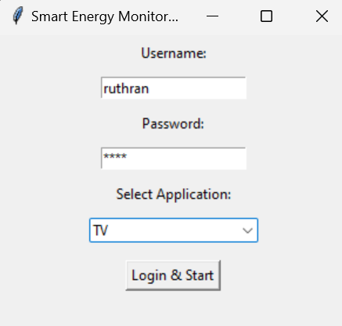

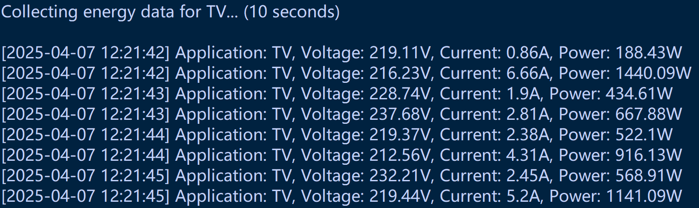

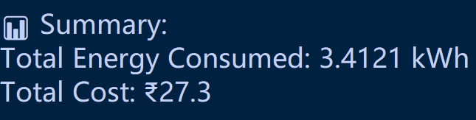

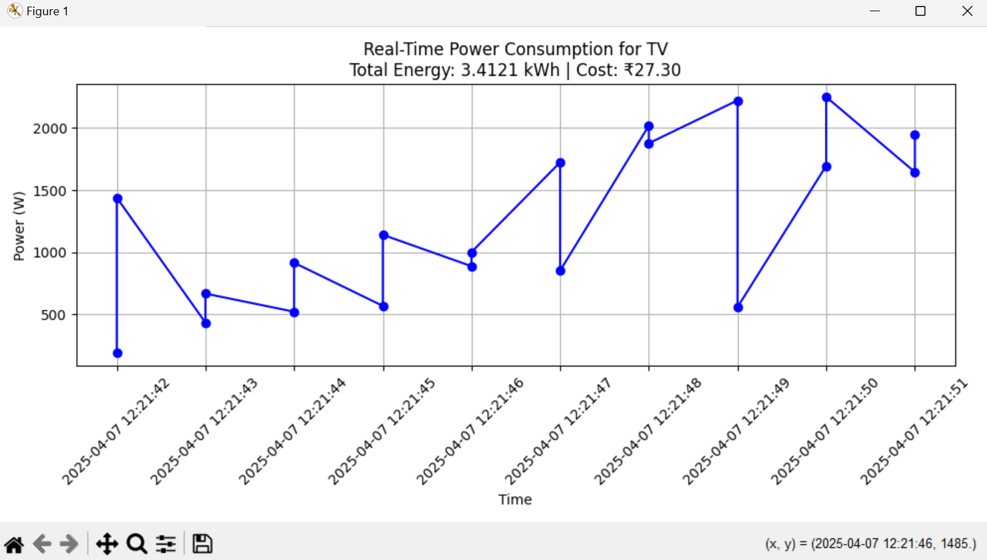

Future Enhancement:
While the current version of the Smart Energy Monitor provides a robust platform for energy simulation and monitoring, there is significant potential for future enhancements to increase its scope, functionality, and real-world applicability. Some of the key areas of improvement include:
- Integration with Real Hardware (IoT):
The most impactful future enhancement would be connecting the application with actual hardware components such as current and voltage sensors, and a Raspberry Pi or Arduino microcontroller. This would allow the system to monitor real-time energy consumption from physical appliances instead of simulated data.
- Cloud Data Storage and Access:
Implementing cloud storage solutions such as Firebase or AWS would allow users to save their energy usage data online. This would make the data accessible from any device, support long-term tracking, and enable remote monitoring.
- Mobile Application Development:
To enhance user accessibility, the project could be extended into a mobile app version (Android/iOS) using frameworks like Kivy or Flutter. This would allow users to monitor their appliance usage from their smartphones or tablets.
- AI-Based Suggestions and Forecasting:
Incorporating machine learning algorithms could help analyze historical data and provide energy-saving recommendations, usage predictions, or alerts for abnormal consumption patterns.
- Multi-User Role Management:
The current application has a basic login system. A future version could implement user roles (admin, standard user, guest), each with different levels of access and functionality.
- Real-Time Notifications and Alerts:
Adding a feature to send alerts via email or SMS when power consumption exceeds a certain threshold can help users take immediate action.
- Billing System Integration:
The application could be enhanced to generate detailed electricity bills based on usage patterns, rate slabs, and tariff plans of various electricity boards.
- Dashboard and Analytics Tools:
A comprehensive analytics dashboard could be developed, featuring daily, weekly, and monthly reports, pie charts, appliance comparison, and downloadable reports.
By implementing these enhancements, the Smart Energy Monitor can evolve into a fully-fledged, scalable, and market-ready energy management solution capable of significantly impacting household and commercial energy conservation.

Conclusion:
The Smart Energy Monitor project presents an effective and user-friendly solution for tracking and analyzing electrical energy consumption in real time. With the increasing global concern about energy conservation and rising electricity costs, this application offers a practical approach for individuals to understand their daily energy usage. By simulating real-time current and voltage readings, calculating power usage, and estimating the cost of energy consumed by household appliances, the system empowers users with valuable insights that encourage responsible energy behavior.
The use of Python, tkinter for GUI development, and matplotlib for data visualization ensures a seamless and interactive experience for users. The application supports secure login functionality, allowing only authenticated users to access the monitoring system, thus maintaining privacy and control. The ability to choose different appliances for monitoring enables flexibility and provides detailed consumption statistics for each device, which can be crucial for users aiming to optimize their electricity usage and reduce wastage.
Moreover, storing the energy data in a CSV file ensures that users have access to historical data, which can be analyzed later for energy pattern recognition and decision-making. The plotted graphs offer a visual perspective, making it easier for users to understand their consumption trends at a glance.
In essence, this project not only meets the core objective of monitoring energy usage in a simulated environment but also opens avenues for integration with real-world systems. It highlights how digital tools can help build awareness and change behavior, thereby supporting energy efficiency and sustainability goals.

